2023 UNITED WAY YOUTH ALLOCATIONS GRANT APPLICATION 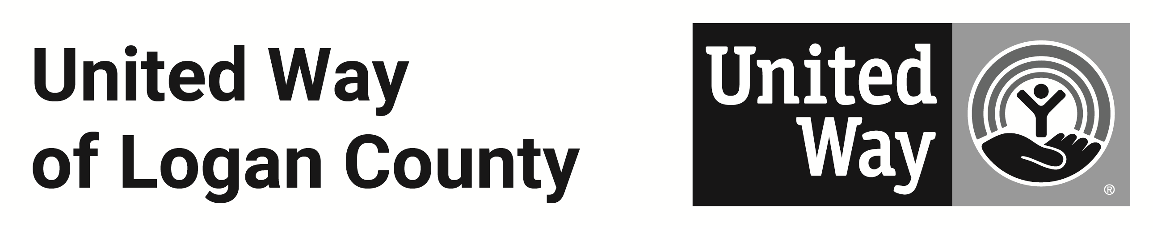
“Student United Way,” is United Way of Logan County’s youth leadership development program. Each year, two juniors and two seniors from each Logan County high school convene over six months to learn about and address the human service needs of our community.

In 2023, the Student United Way committee has at least $25,000 in grant money available to provide to area organizations that provide services to Logan County youth.

CRITERIA
Student United Way is now accepting requests for funding for programs that serve Logan County youth under 18 in the areas of:
- Mental Health, such as but not limited to counseling and outreach so students know where to turn for help, training for school staff to better support students, peer support for youth, High School Challenge Days, awareness initiatives.
- Substance Misuse, such as but not limited to engaging public speakers, anti-drug and alcohol education, anti-vaping programming, prevention, peer support for youth, support for students whose parents/family use drugs, DARE, Neighborhood Outreach Centers.
- Food / Basic Needs, such as but not limited to programs that provide meals / hygiene items directly to youth, either at school or in the community.

The deadline to apply is FRIDAY MARCH 10, 2023. The grants themselves will be awarded by the end of April and can be used either this summer or during the 2023-24 school year.

Type right into this document. E-mail completed application to Melody Couchman at melody@uwlogan.org.
Please call (937) 592-2886 if you have questions or need more information.

Agency / Organization: ________________________________________________________________
Mailing Address: ________________________________________________________________
Contact: ________________________________________________________________
Phone: ______________________________ E-mail: ______________________
NAME OF PROGRAM _________________________________________________________________
Amount requested from United Way: $_________________ Total Program Budget: $________________

Please answer the following questions. Please include NO MORE THAN FIVE LINES of 10-point type for each answer.

1. Description of Proposed Program (Describe services to be delivered, target age group, if youth will be involved in the planning, delivery and evaluation of services) and how the proposed program will impact the target population.

2. Is this a NEW program or ESTABLISHED program? New_____ Established_____
If established, please provide a brief history. If new, how do you plan to sustain your program into the future?

3. What type of experience does your agency / organization have working in this field?

4. Program Goals and Objectives (Include specific measurable objectives for service delivery)

5. Awareness and Access (How will youth find out about this program? How will they get there, or access your service?)

6 Evaluation Plan (Indicate how the effectiveness of the program will be evaluated. If this is an established program, please provide past evaluations.)

7. Volunteer Component (Might there be volunteer opportunities for youth to participate in your project?)

8. Other Funding Sources (please list your other funding sources for this program and the amounts you expect to receive)

9. Program Budget (include income and expenses for the entire program). SPECIFY EXACTLY HOW THE UNITED WAY DOLLARS WILL BE USED, line item-by-line item.

10. What would happen if United Way awarded only partial funding toward your request?

Return by FRIDAY MARCH 10, 2023:
Melody Couchman
United Way of Logan County
melody@uwlogan.org
653 S. Main St.
Bellefontaine, OH 43311

