2021 UNITED WAY YOUTH ALLOCATIONS GRANT APPLICATION 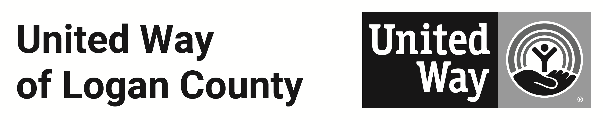
“Student United Way,” is United Way of Logan County’s youth leadership development program. Each year, two juniors and two seniors from each Logan County high school convene over six months to learn about and address the human service needs of our community.

In 2021, the Student United Way committee has at least $20,000 in grant money available to provide to area organizations that provide services to Logan County youth.

CRITERIA
Student United Way is now accepting requests for funding for programs that serve Logan County youth under 18 in the areas of:
- Mental Health, such as but not limited to High School Challenge Days, peer support for youth.
- Substance Abuse, such as but not limited to engaging public speakers, anti-drug and alcohol education, peer support for youth, support for students whose parents/family use drugs, DARE, Neighborhood Outreach Centers, safe after-school and summer activities.
- Financial Literacy programming.
- Workforce Development, including but not limited to job shadowing, tours and field trips to local businesses, career days and career fairs.
- Healthy Living, including but not limited to home economics, cooking and meal preparation, diet and nutrition education, summer and weekend food distribution.

The deadline to apply is Tuesday April 20, 2021. Type right into this document. E-mail completed application to Dave Bezusko at dave@uwlogan.org. Please call (937) 592-2886 if you have questions or need more information.

Agency: ________________________________________________________________
Mailing Address: ________________________________________________________________
Contact: ________________________________________________________________
Phone: ______________________________ E-mail: ______________________
NAME OF PROGRAM _________________________________________________________________
Amount requested from United Way: $_________________ Total Program Budget: $________________

Please answer the following questions. Please include NO MORE THAN FIVE LINES of 10-point type for each answer.

1. Description of Proposed Program (Describe services to be delivered, target age group, if youth will be involved in the planning, delivery and evaluation of services) and how the proposed program will impact the target population.

2. Is this a NEW program or ESTABLISHED program? New_____ Established_____
If established, please provide a brief history. If new, how do you plan to sustain your program into the future?

3. What type of experience does your agency / organization have working in this field?

4. Program Goals and Objectives (Include specific measurable objectives for service delivery)

5. Awareness and Access (How will youth find out about this program? How will they get there, or access your service?)

6 Evaluation Plan (Indicate how the effectiveness of the program will be evaluated. If this is an established program, please provide past evaluations.)

7. Volunteer Component (What opportunities would there be for United Way Youth Allocations Committee members to volunteer with this program?)

8. Other Funding Sources (please list your other funding sources for this program and the amounts you expect to receive)

9. Program Budget (include income and expenses for the entire program). SPECIFY EXACTLY HOW THE UNITED WAY DOLLARS WILL BE USED, line item-by-line item.

10. What would happen if United Way awarded only partial funding toward your request?

Return by Tuesday April 20, 2021:
Dave Bezusko
United Way of Logan County
dave@uwlogan.org
130 S. Main St., Suite 109
Bellefontaine, OH 43311

